**Input** − A Turing machine and an input string **w**.

**Problem** − Does the Turing machine finish computing of the string **w** in a finite number of steps? The answer must be either yes or no.

**Proof** − At first, we will assume that such a Turing machine exists to solve this problem and then we will show it is contradicting itself. We will call this Turing machine as a **Halting machine** that produces a ‘yes’ or ‘no’ in a finite amount of time. If the halting machine finishes in a finite amount of time, the output comes as ‘yes’, otherwise as ‘no’. The following is the block diagram of a Halting machine −

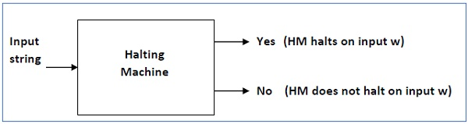

Now we will design an **inverted halting machine (HM)’** as −

* If **H** returns YES, then loop forever.
* If **H** returns NO, then halt.

The following is the block diagram of an ‘Inverted halting machine’ −

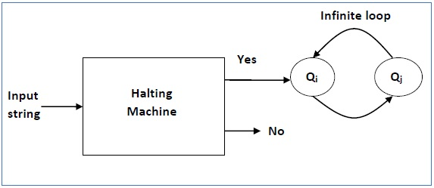

Further, a machine **(HM)2** which input itself is constructed as follows −

* If (HM)2 halts on input, loop forever.
* Else, halt.

Here, we have got a contradiction. Hence, the halting problem is **undecidable**.